Information on tourist spots around Ojiya
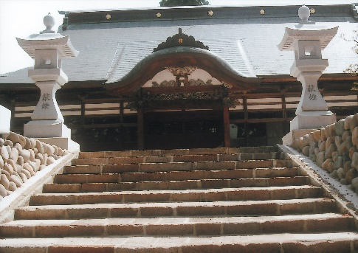
Gochiinn, The First Public Elementary School/ Rōza Ruins(dormitory)

The first public elementary school in Japan started as a boarding school at Gochiinn here in Ojiya. Gochiinn was a school for Buddhist monk and Rōza was a candle factory for the Edo shogunate. After the shogunate collapsed, it became vacant, and it was perfect for dormitory since it had a kitchen, a bath and a storage.
During the battle of Hokuetsu in 1868, after Nagaoka castle was surrendered by the new government army in May, kids of the Nagaoka army came to Ojiya being homeless. However, Ojiya was under control of the new government army and they didn’t allow people to take the kids under their protection. Those kids who had been living in high social class had to survive four months hiding under the floor of a temple or a shrine. They kept off hunger by shoplifting and getting leftovers from restaurants.
As the situation continued, Hiroe Yamamoto who was a crepe fabric dealer couldn’t just stand by. He petitioned the government twice with the risk of his death, and the government agreed in exchange for payment of 1000 ryo(approximately 130 million dollars in current value) in five years. Finally, on October 1st, the first elementary school was opened with a dormitory. It was four years later the government launched “the Education Order”.
Seven notes of student directories and journals which records of 6 years from the establishment are written are still preserved.

Yamamoto went to a private boarding school where he learned Confucianism for six years from twelve and later learned about Shinto. Although he had scholarship to open a private school himself, he devoted himself for establishment of public schools.

If you look around Gochiinn, there is a mystery cave with a maze inside beneath a precipice. It is told that the cave is connected to a cave under the ground of Shinji castle located on the precipice which a famous thief Kazedaijinn dug to hide a lot of gold.

